***Chase Scene Reflection***

For this project, my intention as a cinematographer were to have more ambitious, moving and panning shots throughout the film. I wanted to experiment with different shot and camera movement the different types that could be used throughout filming a fast and exciting scene. I got this as an inspiration from the short film ‘The chase’ which is a short film made by a student, who inspired me to create movement like that with a camera. The fast movements with a variety of shots were what I wanted to do with my film. This had to be done by re-filming shots at different locations multiple amount of types with multiple different angles and experimenting so the editor would have a wide range of shots to edit and work with.

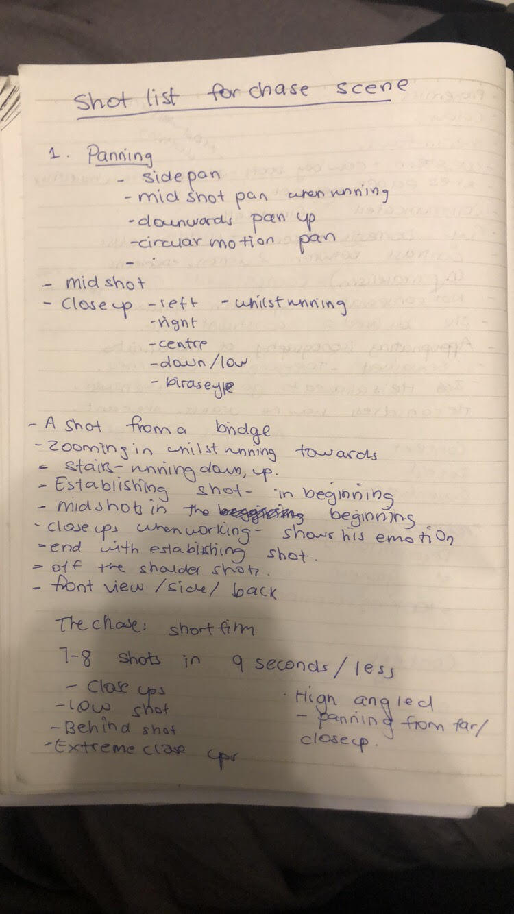

Before achieving all of this, the first thing I did was create a production schedule to plan out the location and days we were filming so I could look at the location beforehand and think of different shots that could be done. Also, I needed to make sure that equipment was booked, as well as having a shot list in mind before filming to make sure that shots were repeated throughout the film. I felt like this shot list did come in handy, but found myself still wanting to be more ambitious with my shots. However, I also needed to run this through the editor to make sure that we were both on the same page with how we wanted this film to turn out. We both ran through the script with each other and got feedback before we proceeded with this film.

Moreover after this, I created a short storyboard for a brief understanding of the different shots I wanted to use. Whilst doing this, I looked at the short film where I took my filmmaker intentions from and created a shot list that I could use towards creating my film. I did not copy it exactly, but I did look at different ideas that could be used. I also collaborated with someone to create music and give them a brief idea of what was wanted when it was being made to add in our film.

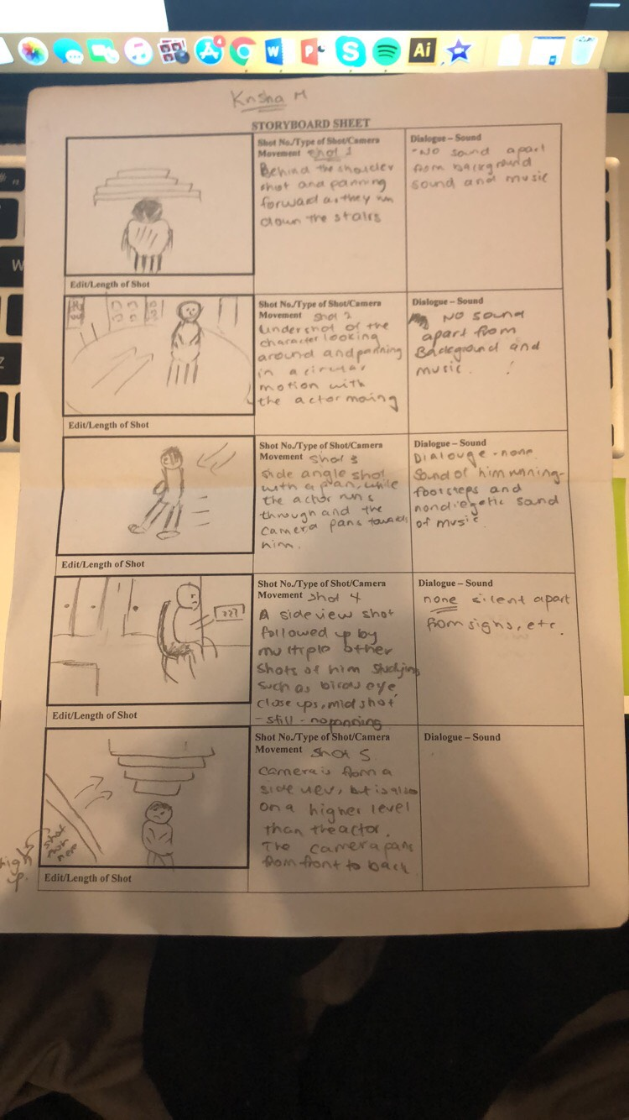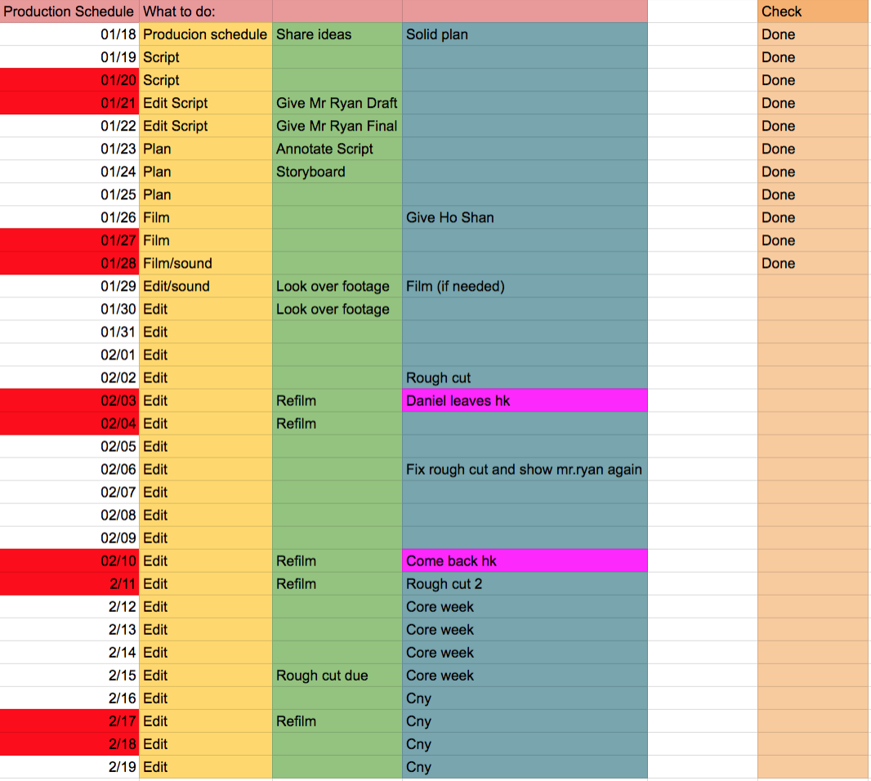

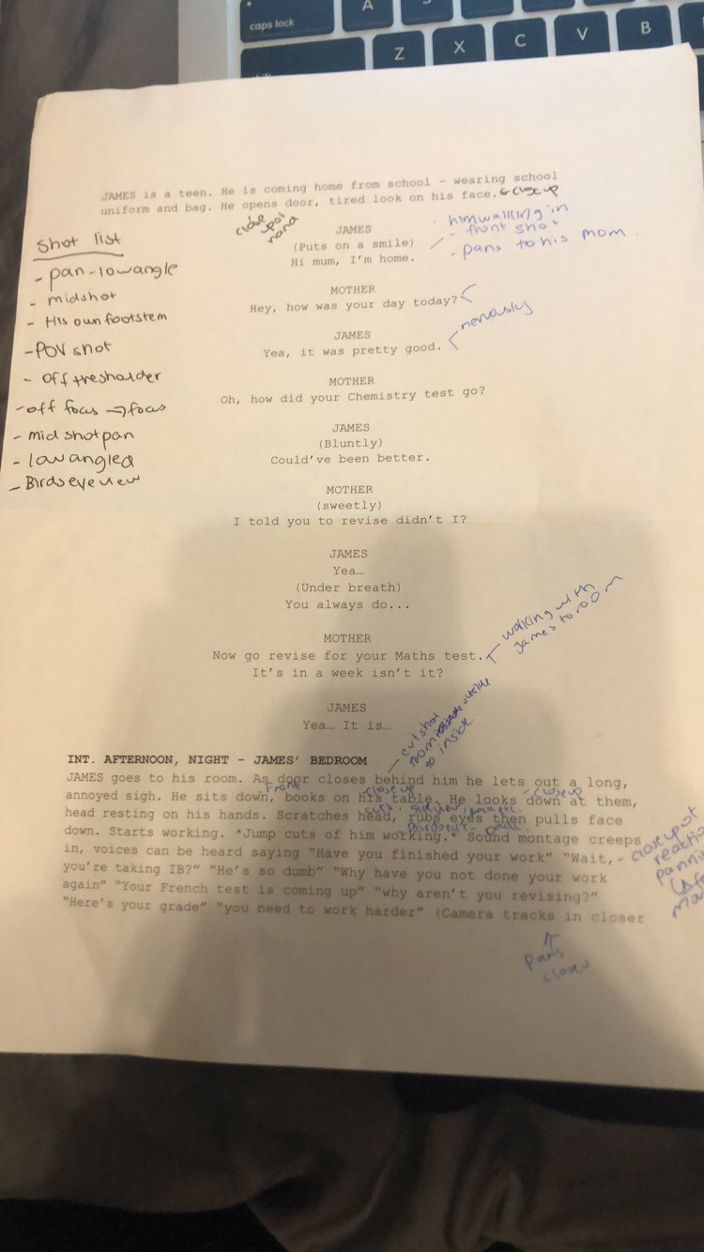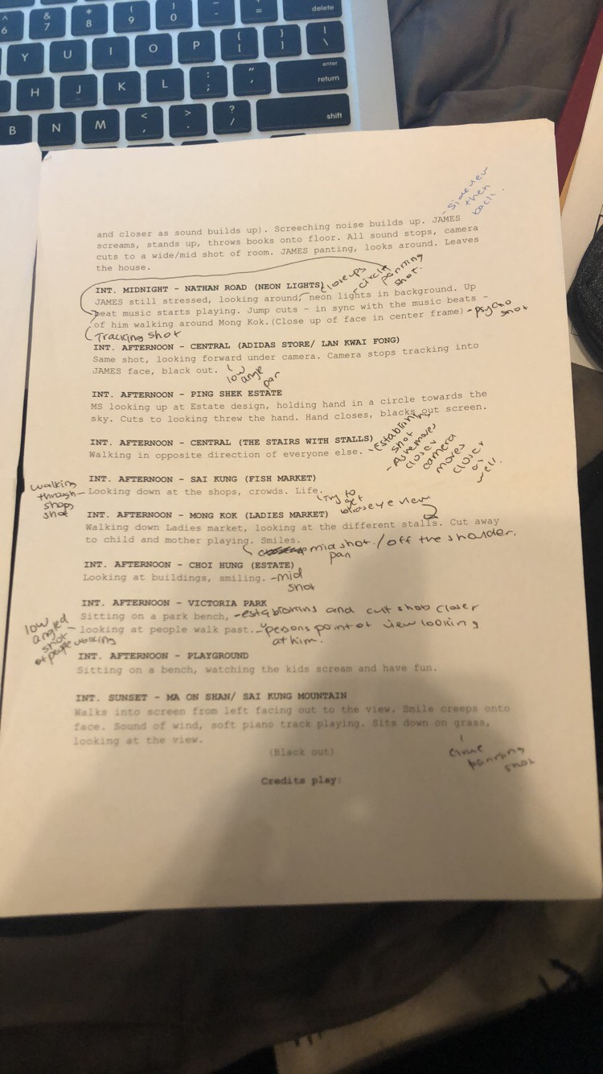

There were problems within this project such as having to have our actor at a certain time that would fit our timetable as well. Apart from this, I felt like I started to go off target in the middle of the film as I started to get confused with what I really wanted cinematography wise. I felt that I was too repetitive with my shots and wasn’t as ambitious as I wanted to be and started to have to rethink the whole thing again. However, we weren’t able to re-film again. But, as I did take a lot of shots, I decided to use some of the other ones instead of having multiple of the same ones throughout the film. This did help solve the problem a little but for future reference I need to make sure that I look at proper films when taking my intentions. I felt like this was the case as I did not research ambitiously as much as I should have and therefore were limited with some of my shots. I did take action as I got feedback from my teacher, who then helped me with my cinematography and understanding movement with the camera. I used another lenses from the DSLR which was one that I wasn’t to familiar with using, but it was something good to learn about for future references.

Overall, I was pleased with what I did with my cinematography as I felt like I experimented more with moving and panning the camera and being a little bit more ambitious compared to my last project as I planned this more. Through the influences, it was shown through having multiple different camera movements in a fast motion in a short period of time, as well as a similar genre of film. I also spent time learning how to use a new lens. However, it did take some time to get used to. In the future, I do however , want to experiment with using a different camera, as I am so use to using a DSLR, when I there were multiple other ones that I could have used Additionally, when it came to the location, I didn’t look at the lighting as well as I should have which is something I have to take into consideration as it’s so important to have the right lighting for the right timing.